Why Python?
Python is highly suitable for rapid GUI prototyping, data analysis, GIS (geographic information systems), and machine learning tasks. It has robust libraries for working with spatial data and creating web applications.
Technology | Why | Alternatives | Why not Alternatives
Language | Python  - Widely used for scientific, simulation, and GIS tasks.  - Large ecosystem for mapping and data science.  - Easily integrates with visualization and AI tools.  - Rapid prototyping, readable syntax.  - Used in commercial and academic evacuation systems | Java, C++,  MATLAB,  R | - Higher complexity for rapid GUIs or data handling.  - Less intuitive for beginners.  - Slower prototyping.  - Smaller number of specialized evacuation packages.
GUI (Graphic User Interface) | Streamlit  - Very fast to create interactive web apps with Python.  - No front-end coding needed.  - Excellent for dashboards and real-time feedback.  - Easily integrates with mapping libraries. | Flask,  Django,  Dash,  Tkinter | - Flask/Django/Dash need more manual setup and web knowledge.  - Dash less intuitive for mapping.  - Tkinter not web-based.
Search Algorithm | A* (A-star)  - Finds optimal routes, adapts fast to changes (blockages, risk).  - Well-studied and implemented in evacuation studies and GIS engines ​.  - Uses both travel cost and heuristic for efficiency.  - Proven critical in dynamic hazardous scenarios | Dijkstra,  Greedy,  Custom Heuristics | - Dijkstra is slower for large networks without heuristic.  - Greedy misses safest/shortest routes if hazards change.  - Custom algorithms less tested, may not guarantee optimal paths in emergencies.

CODE (Overview)
1. Import Statements
import streamlit as st - Loads Streamlit, which is used to create the interactive web user interface.
import folium - A mapping library for rendering geographical maps and paths.
from streamlit_folium import st_folium - Allows Folium maps to be embedded in Streamlit apps for user interaction.
import xml.etree.ElementTree as ET - Handles XML parsing—specifically for extracting route data from KML files.
import numpy as np - Used for numeric operations, especially for fuzzy logic calculations.
import skfuzzy as fuzz - Provides fuzzy logic functions to rate path difficulty based on slope, travel time, and curvature.
import pandas as pd - Reads Excel files containing travel segment data.
import os - Used for file and directory handling.
import heapq - Implements a priority queue needed by A* pathfinding.
from math import radians, sin, cos, sqrt, atan2 - Math functions for accurate geodesic distance calculations.
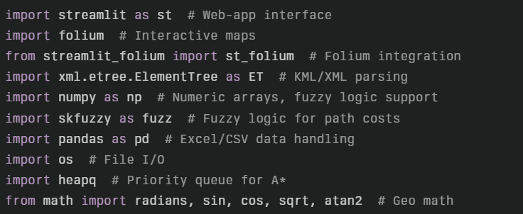

2. EvacuationSystem Class Initialization
- Stores file paths, prepares data structures, loads barangay coordinates, edge distances, blocked paths, and sets up the routing graph.
- On startup, calls functions to load KML paths and Excel travel data if the sources are available.
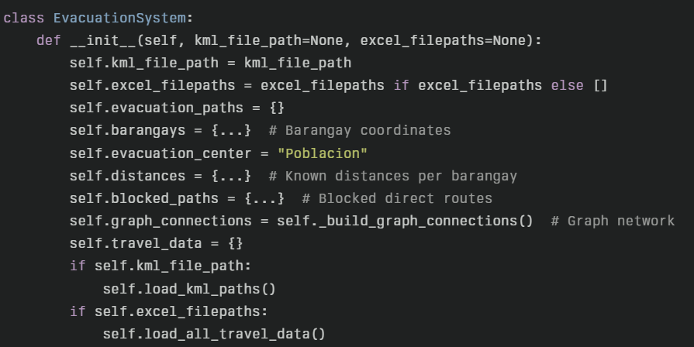

3. Graph Structure Method
- _build_graph_connections: Defines how each barangay is connected to its neighbors. This adjacency dictionary forms the graph the pathfinding algorithm will traverse.
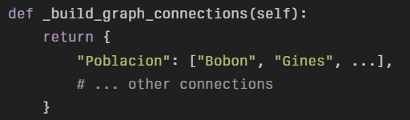

4. Geo Distance Calculation
- haversine_distance: Computes distance between two sets of latitude/longitude using the haversine formula (returns value in kilometers). Used for both path cost and as a heuristic for A*.
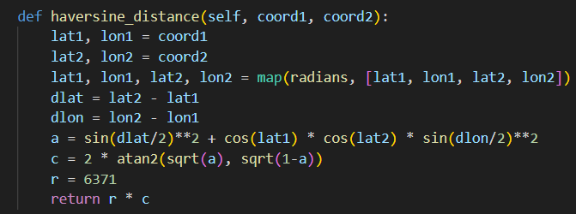

5. A Heuristic Function*
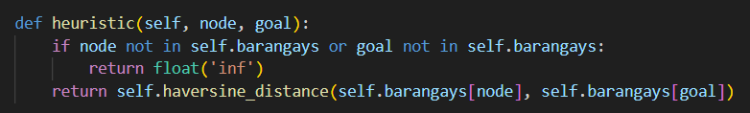
- heuristic: Uses the haversine distance to estimate the cost to reach the goal from a given node in the graph. Helps A* pick promising nodes first.

6. Edge Cost Function
- get_edge_cost: Calculates the cost and travel time between two barangays either from real data (Excel, using fuzzy logic) or by estimation based on straight-line distance. These costs help rate which paths are safest/fastest.
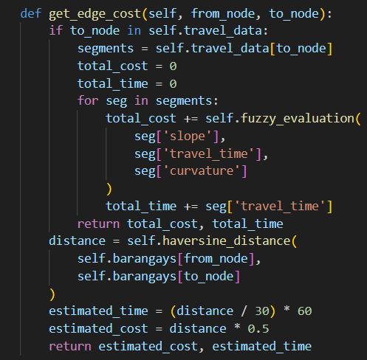

7. KML Loading
- load_kml_paths: Parses the evacuation routes from a KML file, extracting each path's name and associated coordinates. This information is used for both map visualization and path analysis.
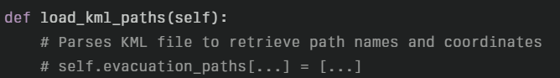

8. Excel Travel Data Loading
- load_all_travel_data: Reads each segment's slope, travel time, and curvature from Excel files, storing the detailed route data for cost calculation.

9. Fuzzy Logic Evaluation
- fuzzy_evaluation: Rates how difficult each segment is based on slope (hilliness), travel time, and curvature using fuzzy logic rules.
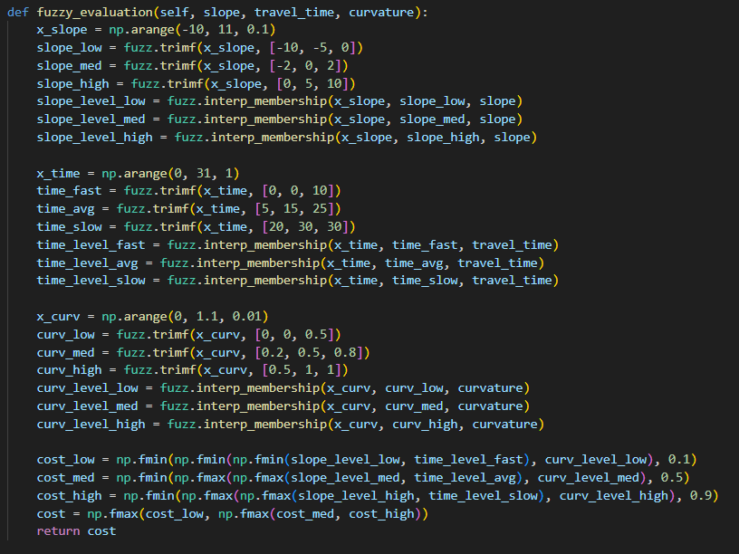

10. Related Routes and Greedy Path Selection
- get_related_paths: Finds all KML path options between the evacuation center and a target barangay.
- best_unblocked_path: Scans related paths for those not currently blocked and picks the one with minimum distance (greedy, not optimal for multi-hop or complex scenarios).

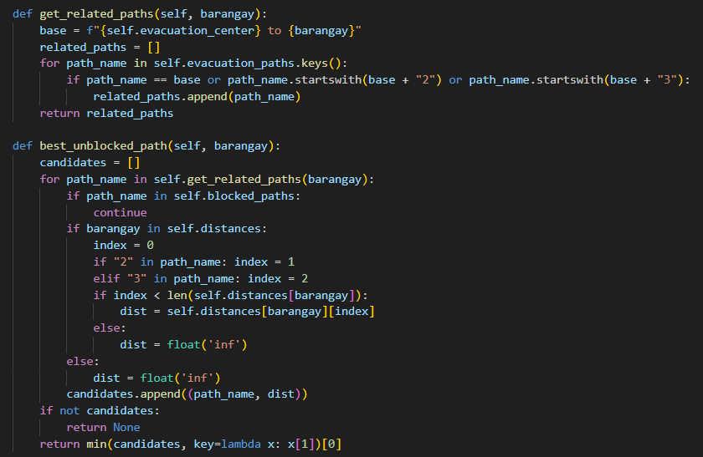

11. A Pathfinding Algorithm Integration*
- a_star_route: This method implements the classic A* search, which:
  - Uses open/closed sets and heapq to efficiently pick the lowest-cost next step,
  - Considers blocked paths,
  - Calculates actual edge cost from real or estimated travel data,
  - Traces back from the goal to reconstruct the optimal route (series of barangay names).
- A* ensures the found route is truly optimal (minimum risk/cost) even if it has to follow a multi-hop path avoiding blocked segments.
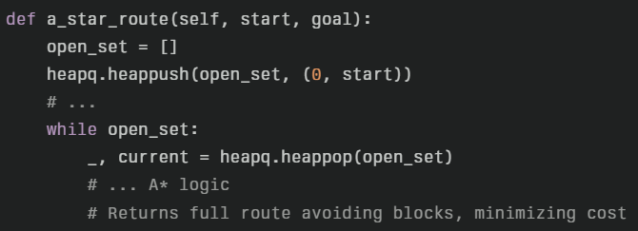

12. Map Visualization
- create_evacuation_map: Builds an interactive Folium map centered on the evacuation center. Colors barangays, highlights the selected path (using the route from A*), and overlays all direct/alternate routes with correct color codes for blocked (red), best (blue), and others (gray).
- If supplied a full route (from A*), traces it step-by-step with polylines.
- Map from Esri satellite map

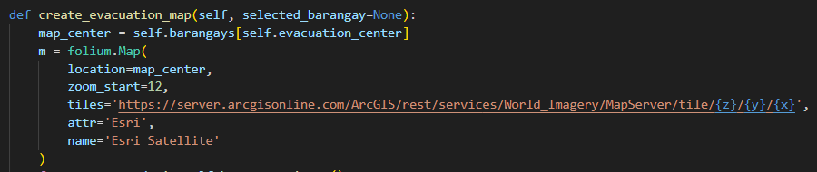

13. Data File Discovery Function
- load_embedded_files: Looks in the data directory for KML and Excel files, returning their file paths for loading.
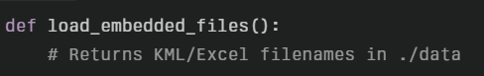

14. Main Function and User Interface
- main: Sets up the Streamlit application with a sidebar featuring usage instructions, system status, and a legend.
- Lets the user select a barangay, runs the A* algorithm to find the optimal route, computes and displays metrics (total distance and time), and shows the route on the map.
- If no route is available due to blocked paths, reports to the user.
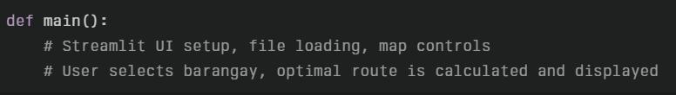

15. Application Entrypoint
- if __name__ == "__main__": main(): Ensures the Streamlit app runs only when the script is executed directly (good programming practice).

